Homework 3

404415073 電機三 蔡孟勳

Question 1 (a)

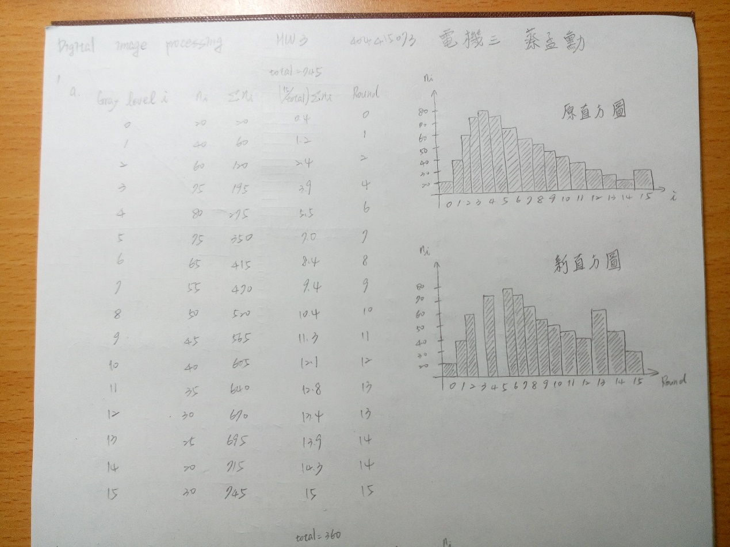

Question 1 (b)

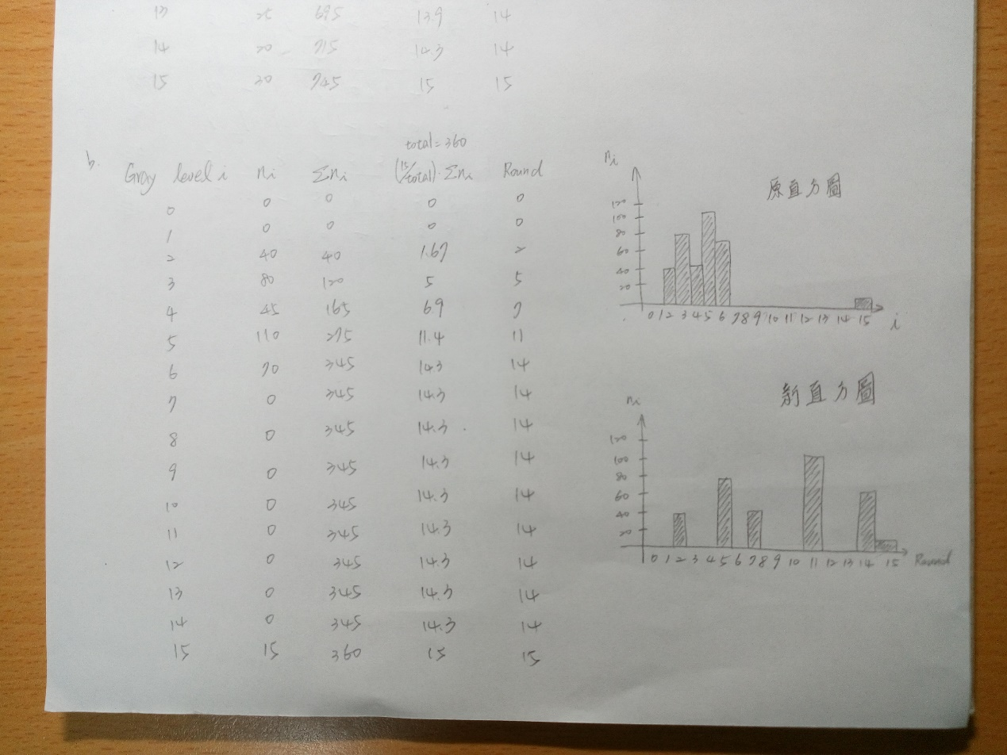

Question 2

